Robotics

**Unit 4 User’s Guide**

Building a Car

horizontal line

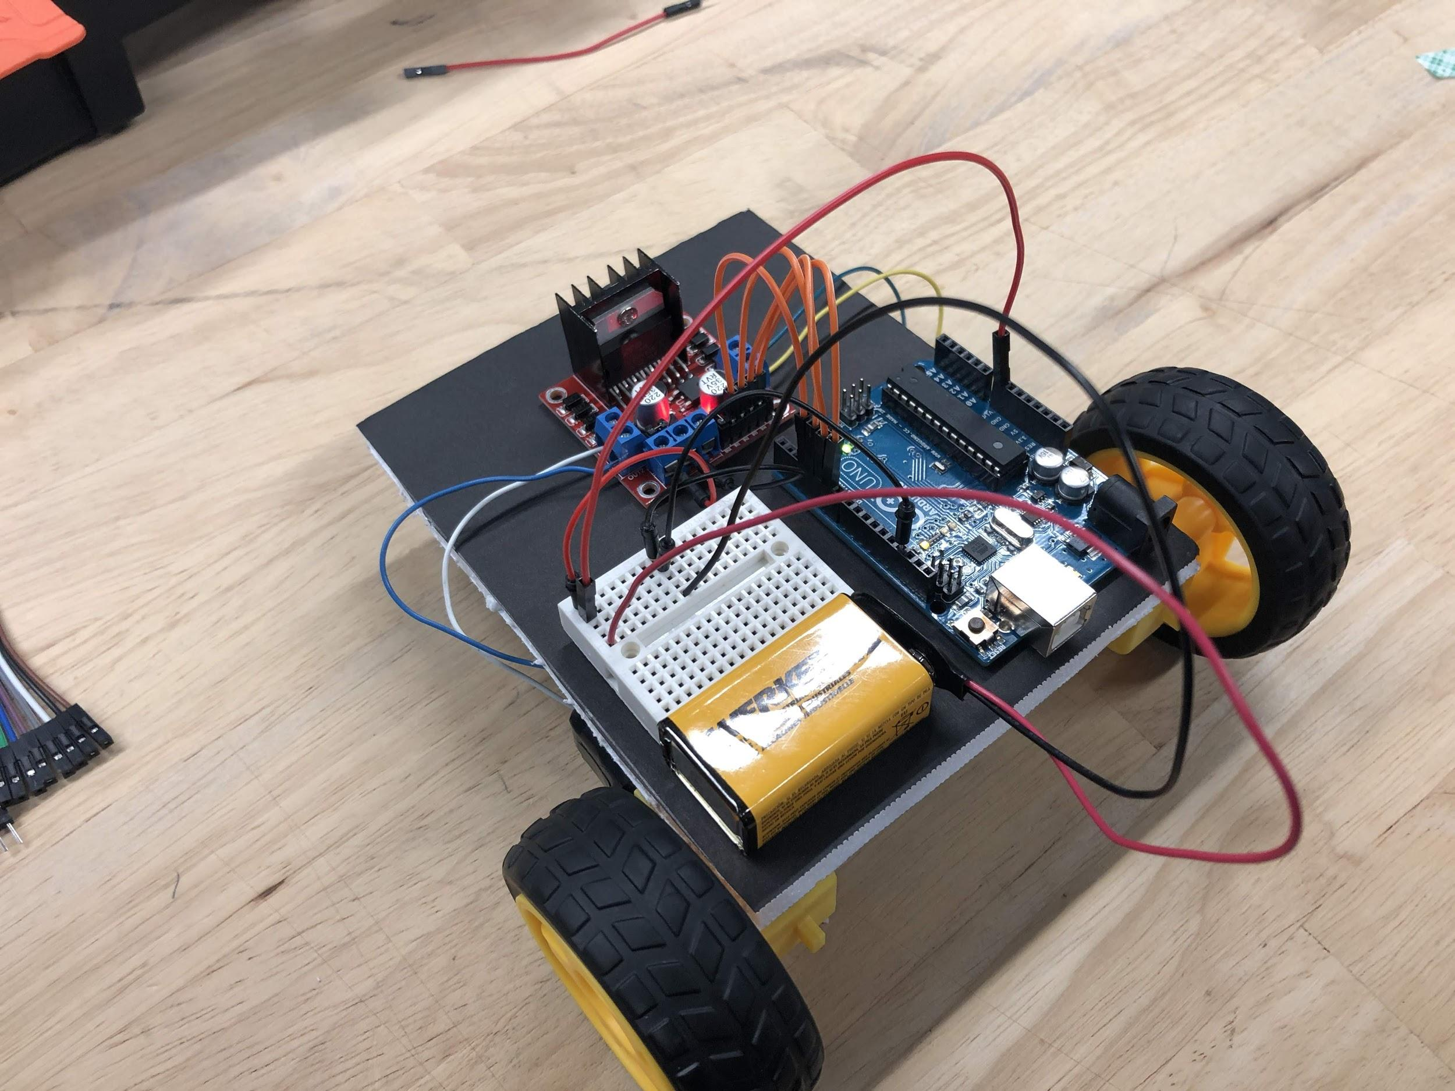

**Ctrl+Alt+Elite**

**CONTENT OF UNIT 4 SLIDES**

**Unit 4 : Building a Car**

**Section 1: H-Bridge Motor Driver**

* H-Bridge Motor Driver mini project assembly
* H-Bridge Motor Driver mini project programming

**Section 2: Building a Car**

* **Car Assembly**
  + H-bridge assembly
  + Arduino assembly
  + Motor assembly
  + Breadboard assembly
  + Ball Bearing assembly
  + Wiring
* **Car Programming** 
  + Arduino IDE program
  + Variations

# OVERVIEW

# Students will learn about L298N H-Bridge Motor Driver and build a basic car using the motor driver and other applied knowledge learned from previous units. In this unit, students will work with their hands to wired up the H-bridge, Arduino and Breadboard. They design a car that can do basics comments such as move forward and backwards. This unit include both programming and hardware wiring.

# OBJECTIVES

* Learn basic problem solving.
* Learn what is an H-bridge and why we use them.
* Learn how to use L298N H-Bridge Motor Driver
* Learn to build a circuit using an H-bridge.
* Build a simple car using the motor driver
* Identify and understand how an H-Bridge motor driver works
* Use an H-Bridge motor driver to control speed and direction of motors
* Build a simple car using knowledge from previous units

# SAMPLE ACTIVITIES

The activities listed below are to completely by the end of this unit. All of them are build using the material covered thus far.

* H-Bridge mini project (Assembly)
  + In this activity students will need assemble the H-Bridge with an Arduino, a power source, a breadboard and a wheel.
* H-Bridge mini project (Programming)
  + In this activity students will need to programmed the assembled circuit build above.
* Assembling the Car
  + In this activity students will need to assemble their car the components provided to them. Placement of the components on the foam is crucial. They need when to place each components so that they have access to it later when they need it.
* Programming the assembled car
  + In this activity students will need to write the program and upload it to the Arduino and check to see if it work as intended.

# WARNINGS AND PRECAUTIONS

* **IMPORTANT:** Never provide power to arduino using both Vin and USB or Barrel Jack.
* **IMPORTANT:** Never join positive and negative battery terminals together.

# INSTRUCTIONS FOR ASSEMBLY

* Assembly instructions (each instruction will be accompanied by a photograph to help understand each instruction
  + Attach the H-bridge such that the leads from the motors can reach the drive pins
  + Attach the Arduino to the foam board (make sure that the proximity of the Arduino to the H-bridge and breadboard are conducive to efficient wiring)
  + Attach the breadboard to the foam board
    - **DO NOT** use the adhesive provided on the back side of the breadboard
  + Attach the Motors with wheels to the back end of the foam on the bottom
  + Attach the Roller bearing to the front-middle of the foam on the bottom
* Wiring the robot
  + Attach the motor wires to the H-Bridge
    - red or yellow motor lead to H-bridge motor +
    - black or blue motor lead to H-bridge motor -
  + Wiring the circuit
    - M/F Jumper wire from Arduino pin 6 to H-bridge IN1
    - M/F Jumper wire from Arduino pin 7 to H-bridge IN2
    - M/F Jumper wire from Arduino pin 8 to H-bridge IN3
    - M/F Jumper wire from Arduino pin 9 to H-bridge IN4
    - M/M Jumper wire from Arduino Vin to H-bridge 5V
    - M/M Jumper wire from Arduino GND to H-bridge GND
  + Connecting the battery
    - 9V battery connector, red wire to 12V on the H-bridge
    - 9V battery connector, black wire to GND pin on the Arduino
* Programming
  + **IMPORTANT**: Never provide power to arduino using both Vin and USB or Barrel Jack
  + Basic H-bridge functions
    - Motor forward (1 pin HIGH, 1 pin LOW)
    - Motor backward (1 pin LOW, 1 pin HIGH)
    - Motor stop (both pins LOW)
  + Functions that simplify these
    - Vehicle forward (both motors forward)
    - Vehicle backward (both motors backwards)
    - Turn right (left motor forward, right motor backwards)
    - Turn left (right motor forward, left motor backwards)
* Variations
  + Using the PWM pins to control motor speed
    - Remove jumpers from ENA and ENB pin on the H-bridge
    - Attach ENA and ENB pins using M/F wire to Arduino pins supporting PWM
      * Pins with ‘~’ label
    - Use *analogWrite([ENA/ENB pin number], [value 0-255])* function to control the speed of the motors

**Bill of Materials**

**List of Materials needed for this unit (per student)**

* 12cm x 12cm foam square
* Double sided tape
* 2 Motors w/ wheels
* H-bridge
* Arduino
* Laptop
* Roller Bearing
* 9V battery
* 9V battery cable
* 4-6 **M/F** jumper wires ( **M**ale to **F**emale)
* 2 **M/M** jumper wires ( **M**ale to **M**ale)
* Scissors